ADIDAS US SALES PERFORMANCE
PROJECT DOCUMENTATION
Name: Aghe Marvellous
Track: Excel Data Track
Project Overview
Project Title: Adidas US Sales Performance Dashboard
Tool Used: Microsoft Excel (Power Query, Power Pivot, DAX, Pivot Tables, Charts)
This project was developed to analyze and visualize Adidas US sales performance using advanced Excel data modeling and time intelligence techniques.
The dashboard provides interactive and executive-level insights into:
- Revenue performance
- Profitability trends
- Product performance
- Sales method effectiveness
- City-level profitability
The solution was built using a structured BI approach:
- Data Cleaning → Power Query
- Data Modeling → Power Pivot
- Analysis → Pivot Tables
- Visualization → Dashboard Design
Problem Statement
A retail company wants to better understand its sales performance, profitability, and sales methods across different time periods, products, and cities.
Although detailed sales data is available, it has not yet been analyzed to reveal:
- Sales trends over time
- Key profit drivers
- Top-performing products
- Most profitable sales methods
- High-performing cities
As a Data Analyst, the objective is to use Microsoft Excel to analyze the provided dataset (Adidas US Sales Data.xlsx) and generate insights that support data-driven business decisions.
Data Overview
Dataset Name: Adidas US Sales Data
The dataset contains transactional sales records including:
- Invoice Date
- Region
- State
- City
- Product
- Sales Method
- Units Sold
- Price per Unit
- Total Sales
- Operating Profit
The dataset serves as the fact table for analysis and was enhanced with a proper Date Table for time intelligence calculations.
Project Questions & Tasks
1. Sales Trend Analysis
- What are the sales trends by year, quarter, and month?
- Are there noticeable seasonal patterns or growth trends over time?
2. Product Performance Analysis
- What is the total sales and total profit generated by each product?
- Which products contribute the most to overall profitability?
3. Profit by Product
- How does total profit vary across different products?
- Which products are the most and least profitable?
4. Sales Method & Profitability
- What is the average profit generated by each sales method?
- Which sales methods are the most effective in terms of profitability?
5. City-Level Profit Analysis
- Which are the Top 5 cities by total profit?
- Visualize this analysis using a funnel chart to highlight performance differences.
Data Cleaning (Power Query)
All data cleaning and transformation were performed in Power Query before loading into the Data Model.
Cleaning Steps Performed:
- Removed duplicate records
- Identified and removed blank/null rows
- Standardized column names
- Ensured consistent formatting across all columns
Data Type Standardization:
- Invoice Date → Date format
- Units Sold → Whole Number
- Total Sales → Currency format
- Operating Profit → Currency format
- Price per Unit → Decimal format
After cleaning and validation, the dataset was loaded into Power Pivot (Data Model).
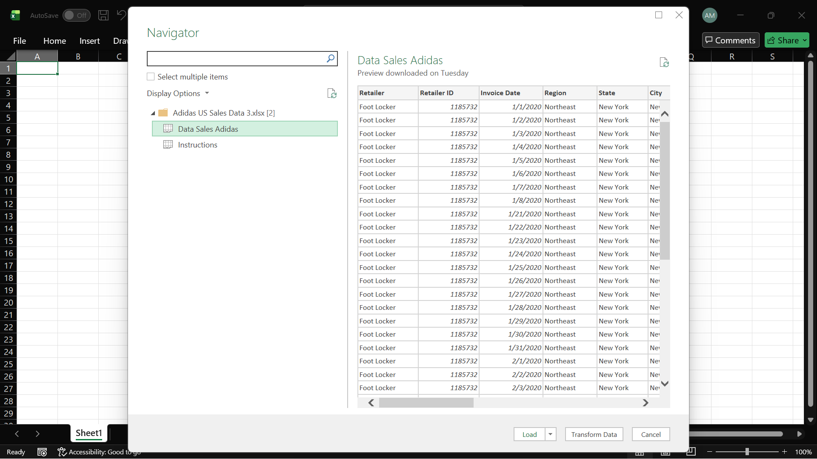
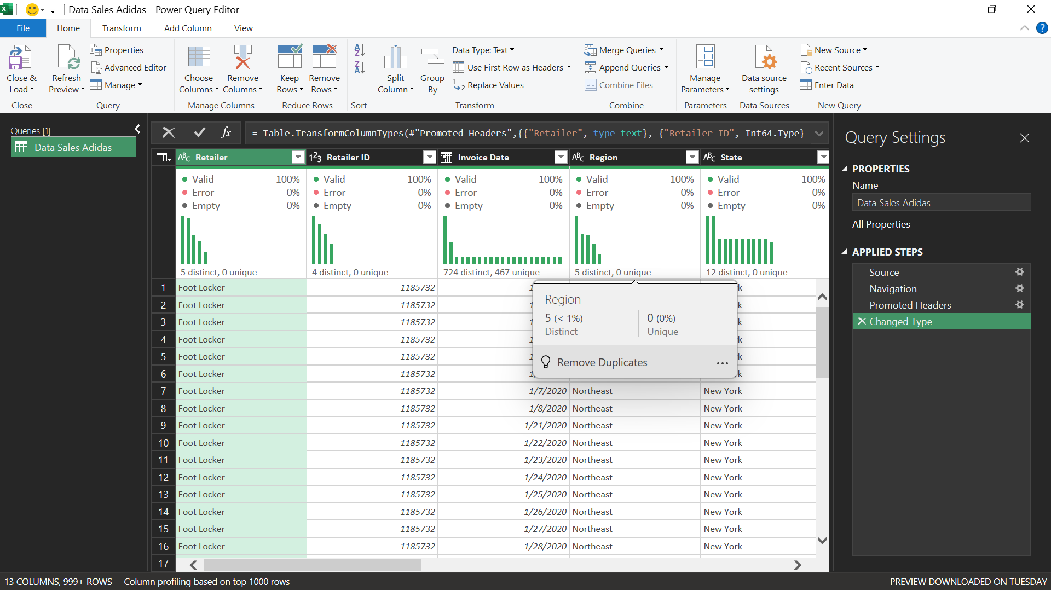
Data Modeling (Power Pivot)
A proper data model was created to enable accurate calculations and time intelligence analysis.
Date Table Creation
A dedicated Date Table was created using DAX:
Date Table =
ADDCOLUMNS(
CALENDAR(MIN(Sales[Invoice Date]), MAX(Sales[Invoice Date])),
"Year", YEAR([Date]),
"Quarter", "Q" & FORMAT([Date], "Q"),
"Month Number", MONTH([Date]),
"Month Name", FORMAT([Date], "MMMM")
)
The Date Table was marked as the official Date Table and linked to the Sales table using:
Sales[Invoice Date] → Date[Date]
This enabled proper Year-over-Year calculations.
KPI Measures (DAX)
Core KPIs
Total Sales
Total Sales =
SUM(Sales[Total Sales])
Total Profit
Total Profit =
SUM(Sales[Operating Profit])
Total Units Sold
Total Units Sold =
SUM(Sales[Units Sold])
Profit Margin
Profit Margin =
DIVIDE(
[Total Profit],
[Total Sales]
)
Previous Year (PY) Measures
Total Sales PY
Total Sales PY =
CALCULATE(
[Total Sales],
SAMEPERIODLASTYEAR('Date Table'[Date])
)
Total Profit PY
Total Profit PY =
CALCULATE(
[Total Profit],
SAMEPERIODLASTYEAR('Date Table'[Date])
)
Total Units Sold PY
Total Units Sold PY =
CALCULATE(
[Total Units Sold],
SAMEPERIODLASTYEAR('Date Table'[Date])
)
Profit Margin PY
Profit Margin PY =
CALCULATE(
[Profit Margin],
SAMEPERIODLASTYEAR('Date Table'[Date])
)
Year-Over-Year (YoY %) Measures
Sales YoY %
Sales YoY % =
DIVIDE(
[Total Sales] - [Total Sales PY],
[Total Sales PY]
)
Profit YoY %
Profit YoY % =
DIVIDE(
[Total Profit] - [Total Profit PY],
[Total Profit PY]
)
Units Sold YoY %
Units Sold YoY % =
DIVIDE(
[Total Units Sold] - [Total Units Sold PY],
[Total Units Sold PY]
)
Profit Margin YoY %
Profit Margin YoY % =
DIVIDE(
[Profit Margin] - [Profit Margin PY],
[Profit Margin PY]
)
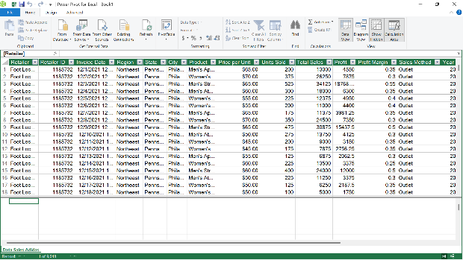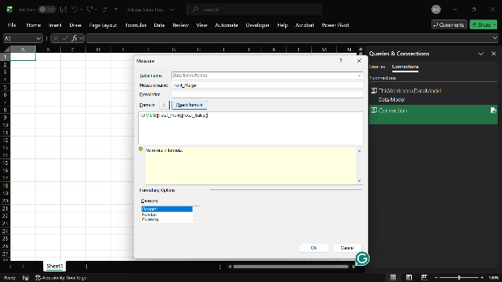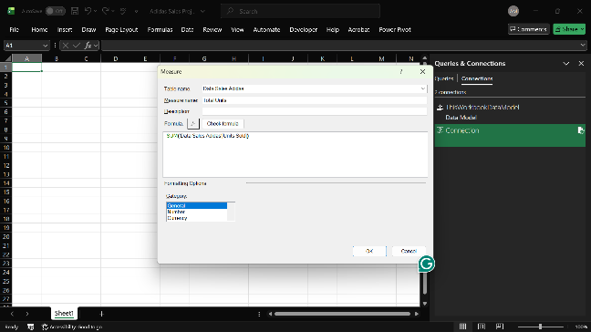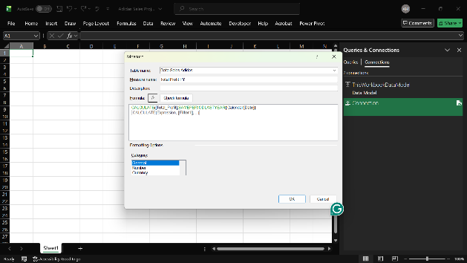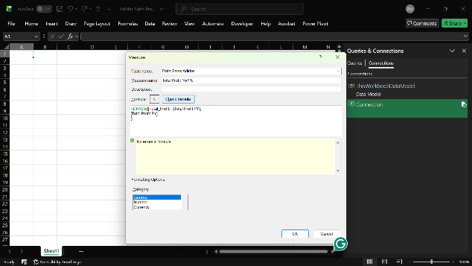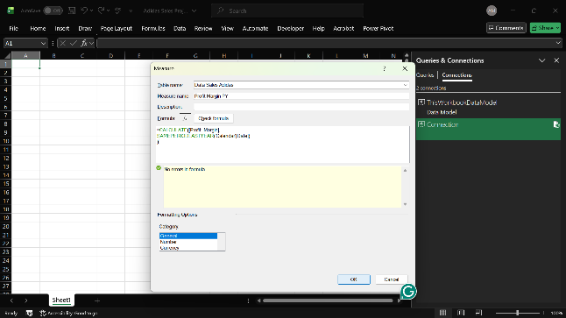
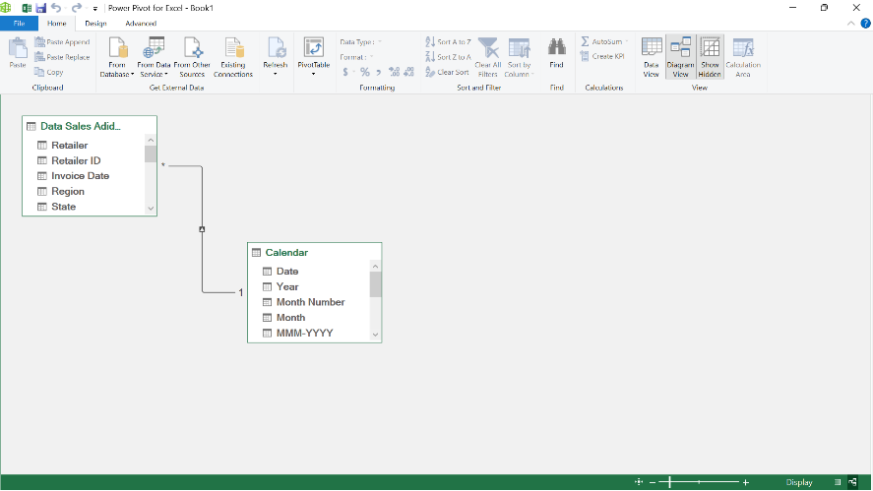
Analysis & Dashboard Development Process
After:
- Data cleaning
- Data modeling
- Measure creation
- Validation of calculations
The dataset was moved into Pivot Tables for structured analysis.
The dashboard was then built using:
- KPI Cards
- Line charts (Monthly trends)
- Bar charts (Product & Region analysis)
- Funnel chart (Top 5 Cities by Profit)
- Slicers for interactive filtering
The dashboard design followed a clean, professional layout using a structured color system and dynamic filtering capabilities.

Insights & Business Recommendations
  - Sales Trend Analysis
Findings
- Sales show strong year-over-year growth between 2020 and 2021.
- Monthly sales indicate fluctuations across quarters.
- Q3 recorded the highest revenue peak.
- There is visible seasonality with stronger performance mid-year.
- YoY growth in Total Sales increased by 396%.
Business Interpretation
- Revenue growth indicates strong market demand.
- Seasonal peaks suggest promotional periods or high-demand cycles.
- The company can leverage high-performing quarters for targeted campaigns.
Recommendations
- Increase inventory and marketing efforts before Q3.
- Launch promotional campaigns during low-performing months.
- Monitor YoY trends continuously to sustain growth momentum.
- Use monthly performance data to forecast future demand.
  - Product Performance Analysis
Findings
- Men's Street Footwear generated the highest total sales.
- Women's Apparel and Men's Athletic Footwear also performed strongly.
- Some products contribute significantly more to total revenue.
- Profit contribution is uneven across product categories.
Business Interpretation
- Revenue concentration is driven by a few top-performing products.
- Some categories may require pricing or cost optimization.
Recommendations
- Allocate more marketing budget to high-performing products.
- Reassess pricing strategy for lower-performing categories.
- Explore bundling strategies for weaker product lines.
- Focus inventory planning on best-selling products.
  - Profit by Product
Findings
- Men's Street Footwear is the most profitable product.
- Women's Athletic Footwear shows lower profit contribution.
- Profit margins vary significantly across products.
Business Interpretation
- High revenue does not always equal high profitability.
- Cost structure may differ across product categories.
Recommendations
- Optimize production costs for low-margin products.
- Review supplier contracts for less profitable items.
- Prioritize high-margin products in promotions.
  - Sales Method & Profitability
Findings
- In-store sales generated 45% of total profit.
- Online sales contributed 30%.
- Outlet contributed 25%.
- In-store is currently the most profitable channel.
Business Interpretation
- Physical retail still plays a dominant role.
- Online sales are strong but have growth potential.
Recommendations
- Strengthen online channel marketing strategies.
- Improve digital customer experience.
- Analyze cost differences between sales methods.
- Explore expansion of high-performing channels.
  - City-Level Profit Analysis
Findings
Top 5 cities by total profit:
- New York
- Charleston
- San Francisco
- Miami
- Portland
New York generated the highest profit.
Business Interpretation
- Profitability is concentrated in key metropolitan areas.
- Urban centers are major revenue drivers.
Recommendations
- Expand distribution and marketing in top-performing cities.
- Study customer behavior in these cities to replicate success.
- Evaluate performance of underperforming cities for improvement.

Business Challenges Identified
Before this analysis, the business faced:
- No clear visibility into sales trends over time.
- Limited understanding of which products drive profitability.
- Unclear performance comparison between sales channels.
- No identification of top-performing cities.
- Difficulty measuring year-over-year growth.
This limits strategic decision-making and resource allocation.

Technical Challenges Faced During Project
- Calculating Profit Margin
- Data formatting inconsistencies.
- Lack of a proper Date Table for time intelligence.
- Ensuring accurate YoY calculations using DAX.
- Designing a clean but information-rich dashboard layout.
These were resolved using Power Query cleaning, structured data modeling, and proper DAX measures.

Business Problems & How the Analysis Fixed Them
1. Problem: No Clear View of Sales Trends
The business did not have a clear understanding of how sales were performing over time. There was no structured way to see yearly, quarterly, or monthly trends.
How the Analysis Fixed It
- Created Year, Quarter, and Month breakdown using a Date Table.
- Built Sales Trend charts.
- Calculated Year-over-Year (YoY) growth.
Now the company can clearly track growth, identify seasonal patterns, and plan better.
2. Problem: Unclear Product Profitability
The company did not know which products were generating the most profit or which ones were underperforming.
How the Analysis Fixed It
- Calculated Total Sales and Total Profit per product.
- Computed Profit Margin.
- Ranked products by profitability.
Now management can focus on high-performing products and review weaker ones.
3. Problem: No Comparison of Sales Methods
There was no clear comparison between In-store, Online, and Outlet sales performance.
How the Analysis Fixed It
- Calculated profit by sales method.
- Measured contribution percentage of each channel.
- Visualized results using charts.
Now the business can identify the most profitable sales channel and improve weaker ones.
4. Problem: No Identification of Top Cities
The company did not know which cities were generating the highest profit.
How the Analysis Fixed It
- Calculated total profit by city.
- Identified the Top 5 cities.
- Visualized results using a funnel chart and map.
Now the company can focus marketing and expansion efforts in high-performing cities.
5. Problem: No Year-Over-Year Growth Measurement
The business could not measure performance growth from one year to another.
How the Analysis Fixed It
- Created Previous Year (PY) measures.
- Calculated YoY % for:
  - Total Sales
  - Total Profit
  - Units Sold
  - Profit Margin
Now growth can be tracked and compared properly.

Conclusion
This analysis transformed raw sales data into clear, structured insights.
The dashboard now allows the business to:
- Track performance over time
- Identify profitable products
- Compare sales channels
- Recognize top-performing cities
- Measure yearly growth

